Required Components
1.   or  or   | 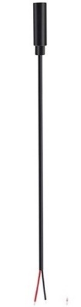  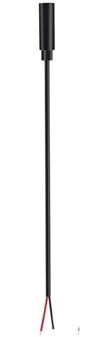      2. | BOM  - Monster Jam RC Car, multiple varieties. Either: El Toro Loco, Megalodon or Marvel Iron Man  - (4x) 3.5 mm Female Mono Cable  - 3D Printed Cable Clamp  - (2x) #4 3/8” screws  - (5x) AAA batteries  Refer to the Tool and Component List for purchasing details.
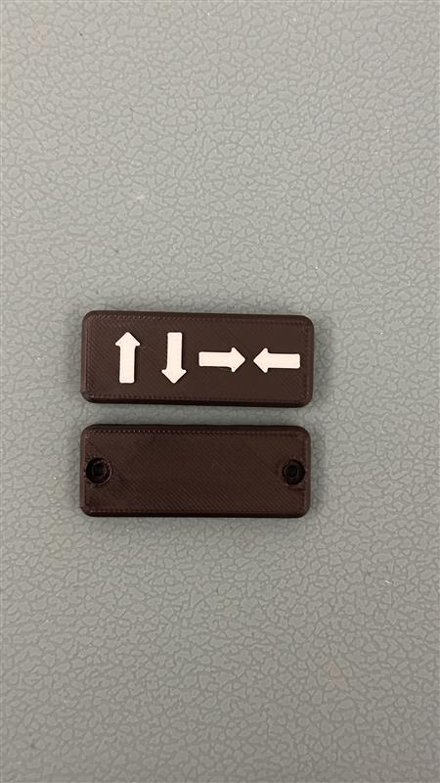  3. | 4.  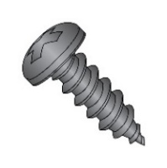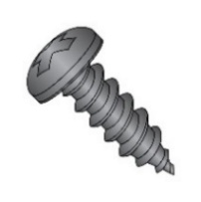 | 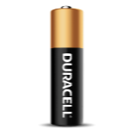          5.

Required Tools
- Phillips Screwdriver
- Wire strippers
- Soldering iron and solder
- Drill and 1/8” drill bit

Required Personal Protective Equipment (PPE)
- Safety glasses

Assembly Instructions
- Carefully remove the toy from its packaging without damaging it (we will be repackaging the toy after adapting). Locate and remove the 2 screws on the back of the remote control. | 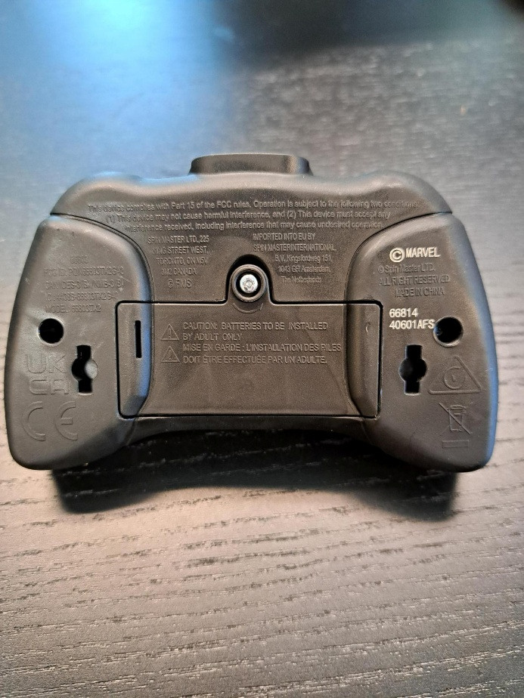
- Carefully separate the two halves of the remote and remove the joystick toppers. | 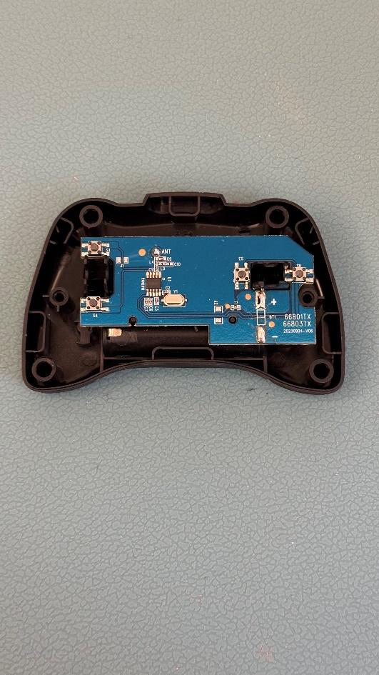
- To prepare the mono cable, use wire strippers to strip approximately 2 cm off the outer wire casing, revealing two internal wires. Repeat for all four mono cables.  Note: your mono cables may come prepped and ready to solder, with both wires revealed and metal on the ends exposed (skip steps 3-5). | 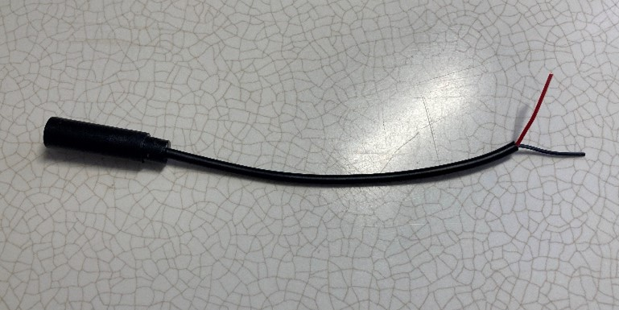
- If there are 2 internal wires, strip approximately 0.5 cm off each wire. | 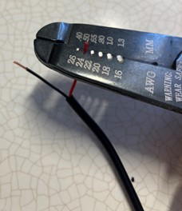
- If there are three internal wires (red, black, and exposed), strip off 0.5 cm of the red insulation and twist the red wire and exposed wire together. Strip 0.5 cm from the black wire. | 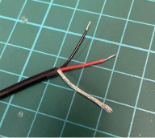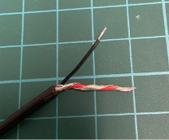
- Melt a small amount of solder over the exposed ends of the wire. | 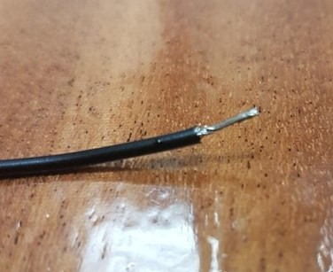
- Using a 1/8” drill bit, drill 4 holes into the positions shown on the right. Remove any loose plastic. | 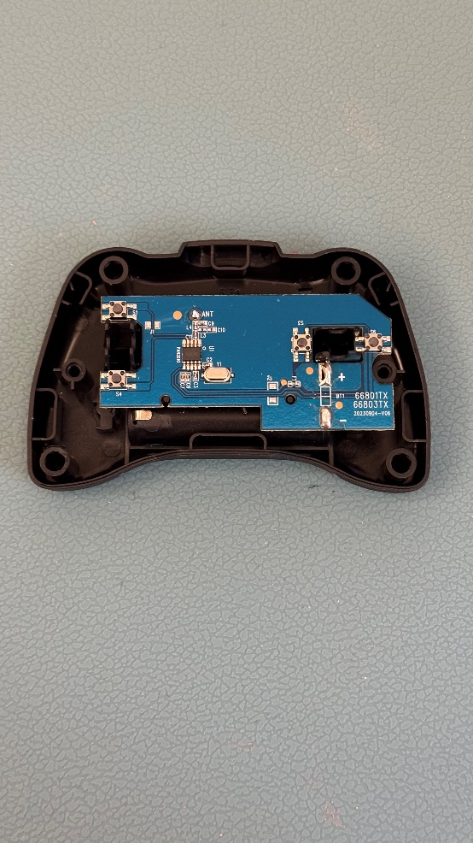
- Insert the mono cables through the holes.
For each mono cable solder the two leads to the two matching circles shown on the image. Make sure to not get solder on a prong that is not meant to be soldered.
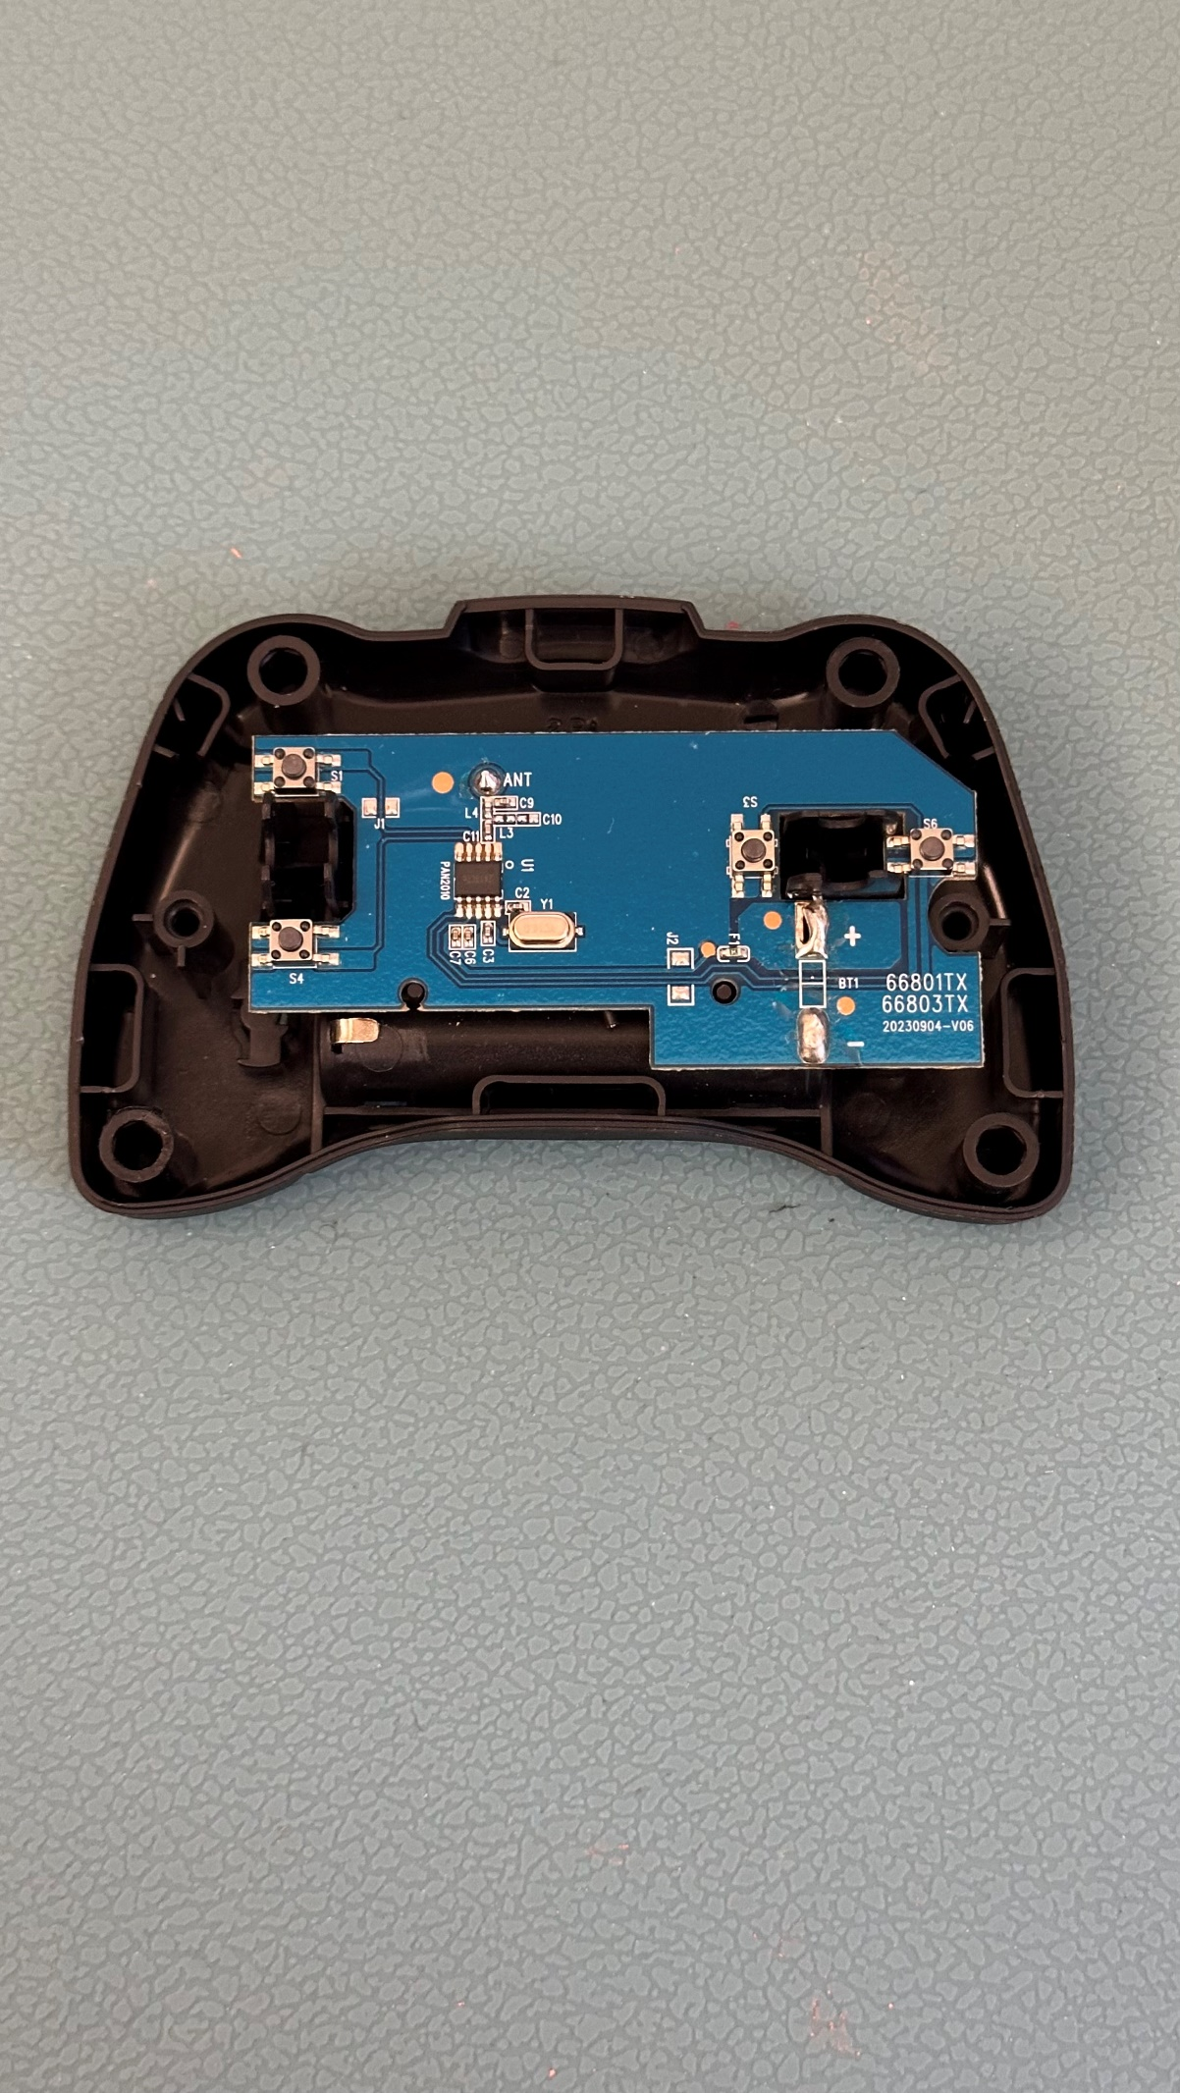
- This is what the soldered mono cable will look like. | 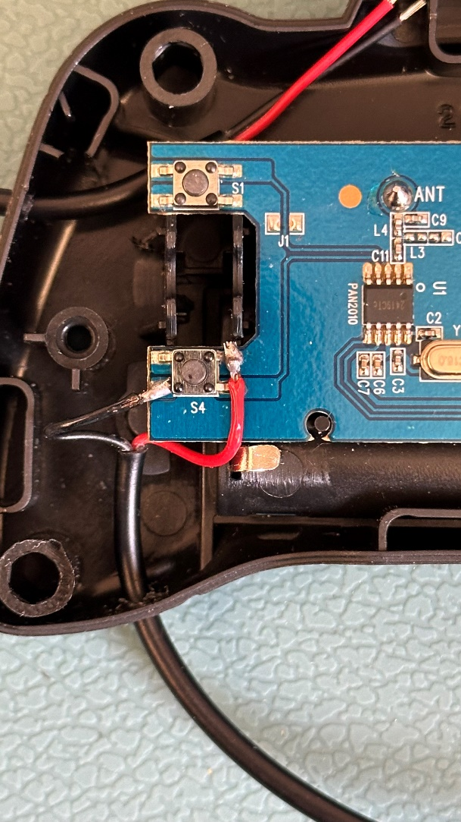
- After finishing each mono cable, test it. Insert the batteries into the remote and car and turn the car on. Plug in an assistive switch. When you activate the switch, the car will perform the function of the button you soldered the cable to (Forward, Backward, Left, Right).  If the car does not move, make sure the batteries are pressed in fully and check the solder connections.  If the car does not stop moving when you release the switch, check the solder connections. | 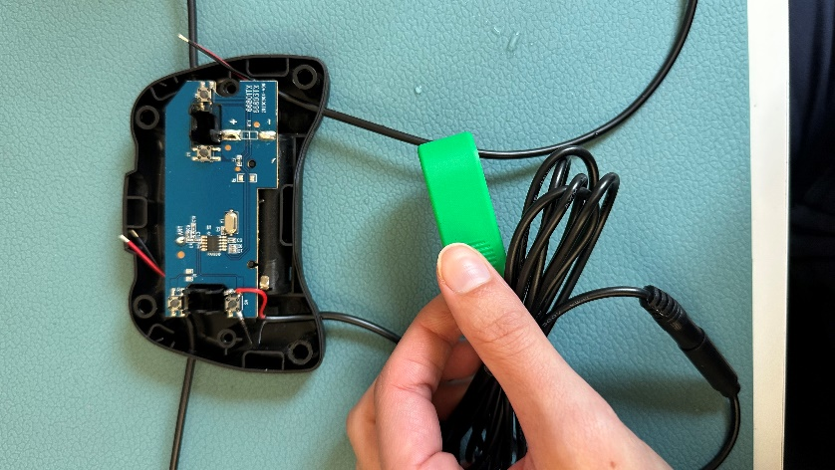
- When you have soldered all four cables, the PCB will look like this: | 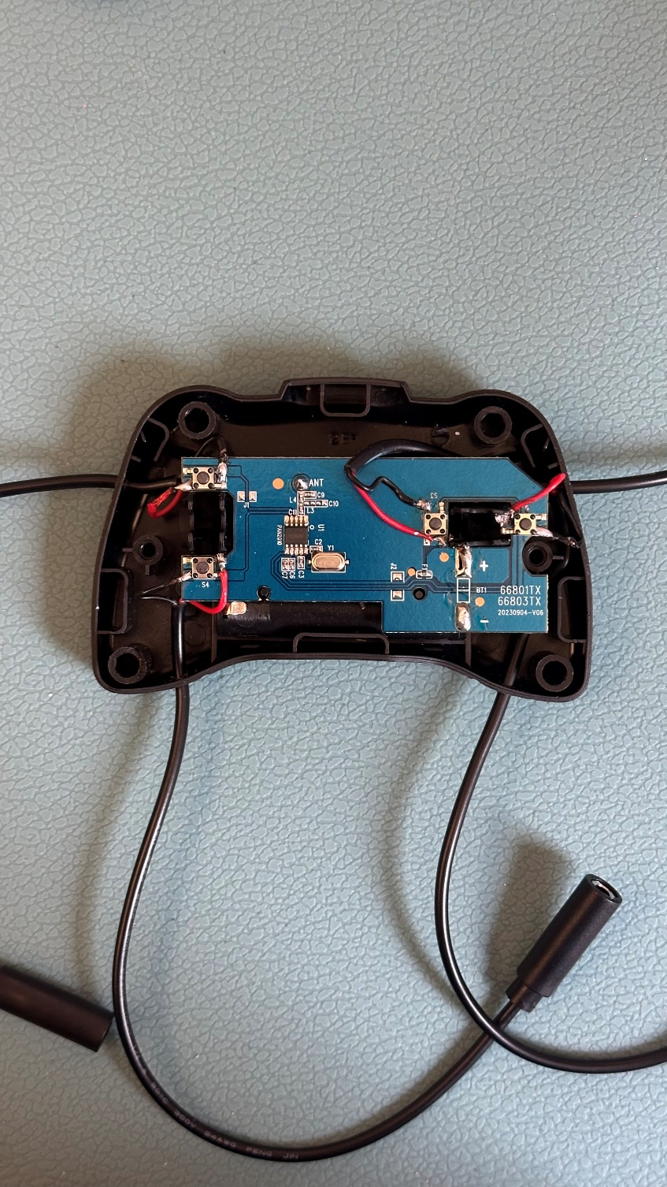
- Gather the mono cables, and put the cable clamp on, ensuring that each wire is lined up with the proper symbol on the clamp.  Insert the screws into the two holes on the back, and tighten to fasten the cable clamp. | 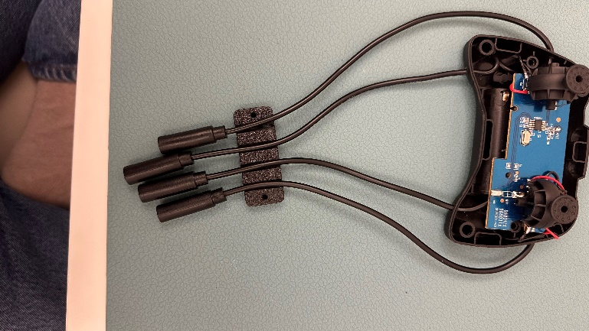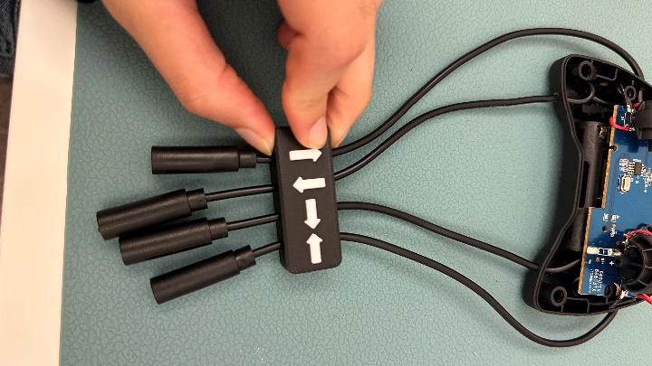  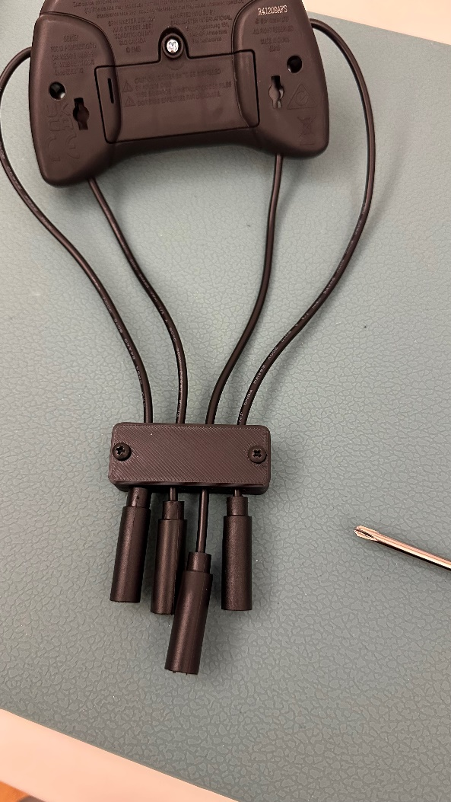
- Place the joystick toppers back on. | 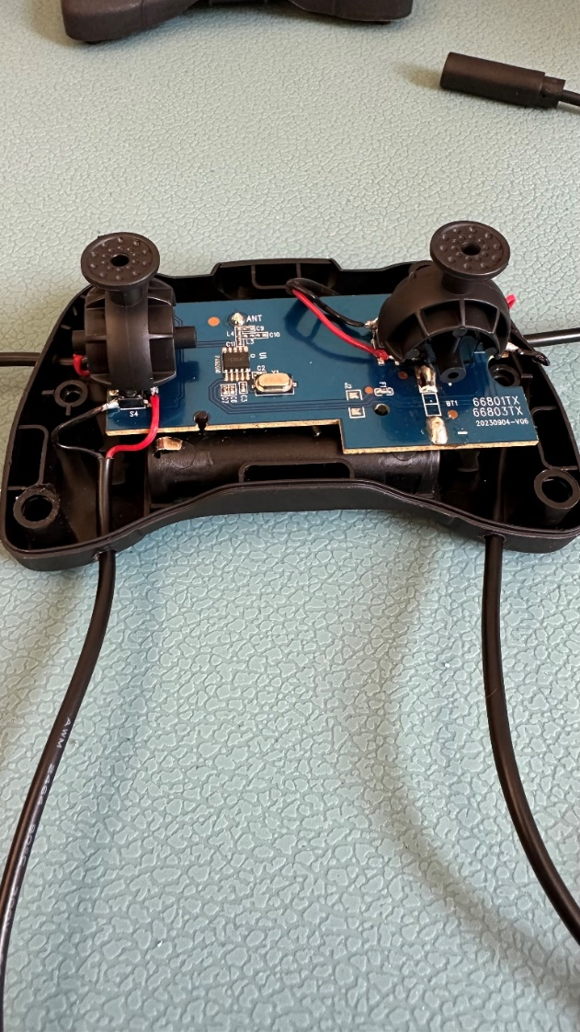
- Close the remote control and insert the two screws back into the remote. | 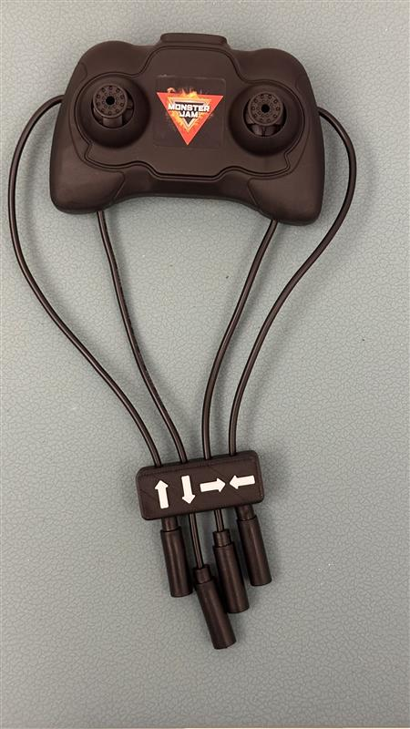
- Test the toy again. If it is still working properly, repackage the toy and the adapted toy is complete! | 